**Cahier de route EPS subsytem for Octanis v0.0. (prior to discussion with the team)**

* 2 batteries LiPo design
* 6 X 2 series solar panels with Zener diode to prevent discharge
* Measure of the current from each set of solar panels (combined as 3 pairs of 2 + 1 individual)
* Measure of the charge // discharge current from batteries (2 currents)
* Measure of the voltage at battery bus (1 voltage)
* Measure of the bus voltage (ensure the regulation is correct)
* Dissipation resistors limited to 2 (heating is a priori not necessary, avoid over-voltage)
* Charge and discharge analogic loops for the batteries with no redundancy (not a space application)
* No temperature is considered (no temperature sensor for the solar panels?? to be discussed), limits a lot the number of components on board. Could consider one temperature on board on a different MSP430 pin (e.g. P6.2 / A2)
* Careful, the design does not support a high voltage from the solar panel,
* Consider putting a LM linear regulator to convert generator entry to 3.3V regulated bus for test purposes (no battery or Solar cell connected)

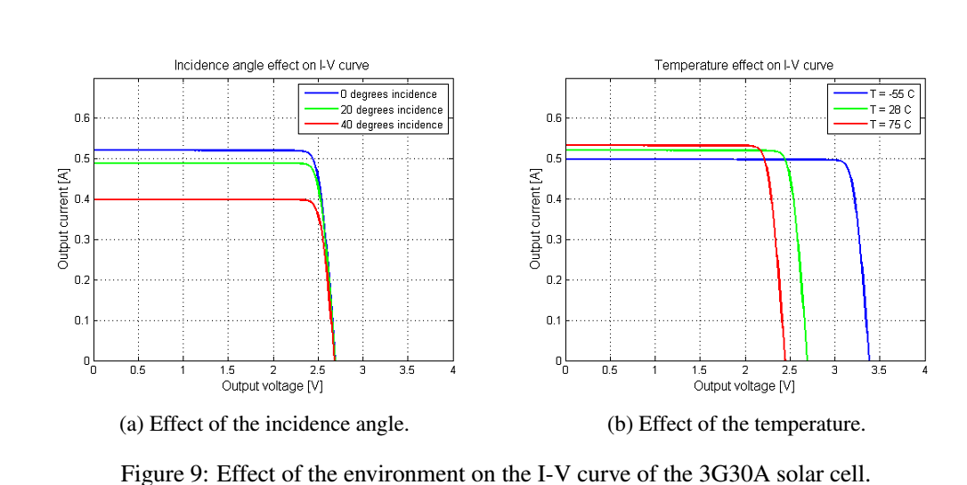

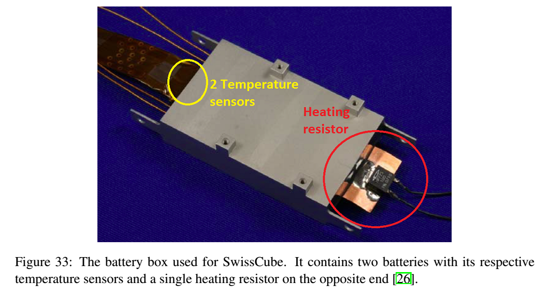

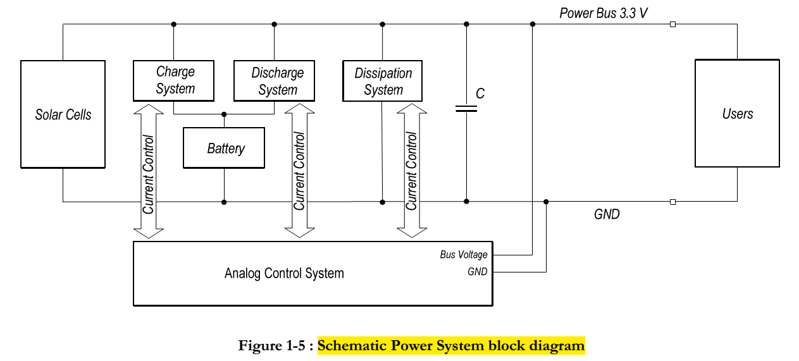

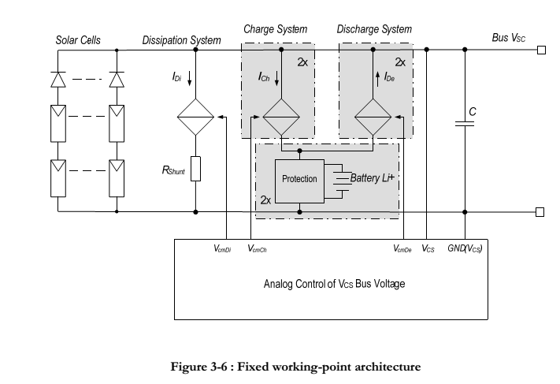

**After discussion baseline for Eagle Octanis_EPS V1.0**

* 2 batteries LiPo design
* **4 X 2** series solar panels with Zener diode to prevent discharge (Top/ bottom)
* Measure of the current from solar panels by face (2 currents, one top one bottom)
* Measure of the charge // discharge current from batteries (2 currents, one positive, one negative)
* Measure of the voltage at battery bus (1 voltage)
* Measure of the bus voltage (ensure the regulation is correct)
* Dissipation resistors limited to 2 (heating is a priori not necessary, avoid over-voltage)
* Charge and discharge analogic loops for the batteries with no redundancy (not a space application) 🡪 **NEW**: the two batteries are in parallel configuration, not independents
* No temperature is considered (no temperature sensor for the solar panels?? to be discussed), limits a lot the number of components on board 🡪 **NEW**: one temperature taken from the battery box! If considered, must be digital, not analog
* **NEW**: use Spy-bi wire for flash and debug, model MSP430F5529. The Spy-bi-wire pins are on pins 71 and 76.
* **NEW**: allow current to be withdrawn for heating (during charge if < -20°C)
* **NEW**: The limited number of analog measures (6 overall) allows to get rid of MUX

